**Dental Clinic Services System**

Project Proposal

By

**Kanokwan Maneerat 542115002**

**Worapun Wongkium 542115055**

Department of Software Engineering

College of Arts, Media, and Technology

Chiang Mai University

Project Adviser

______________________________

Mrs. Yun Rim Park

**Project Proposal**

**Revision Table**

|  |  |  |  |  |  |
| --- | --- | --- | --- | --- | --- |
| **Document Name** | **Detail** | **Status** | **Date** | **Viewable** | **Reviewer& Responsible** |
| Our Senior Project(542115002,542115055) | Scope and overview of project | Draft | 1/13/2014 | Adviser | Kanokwan& Worapun |
| SeniorProject_Agent P_09022014 | Cover all project proposal | Draft | 2/9/2014 | Adviser | Kanokwan& Worapun |
| SeniorProject_Agent P_28022014-v 0.3 | Edit all wrong English, milestone and all part of project proposal. | Draft | 2/28/2014 | Adviser | Kanokwan& Worapun |
| SeniorProject_Agent P_03022014-v 0.5 | Edit all wrong English,and using more clear words | Draft | 3/3/2014 | Adviser | Kanokwan& Worapun |
| SeniorProject_Agent P_04032014-v 0.6 | Change milestone, double check English, and add cover page | Draft | 3/4/2014 | Adviser | Kanokwan& Worapun |
| SeniorProject_Agent P_04032014-v 0.7 | Add abstract part and change Milestone with feature | Draft | 3/4/2014 | Adviser | Kanokwan& Worapun |
| Dental Clinic Services System – Proposal – v 0.9 | Add some of reference | Draft | 3/5/2014 | Advisor | Kanokwan& Worapun |
| Dental Clinic Services System – Proposal – v 1.0 | Add feature and Table of content | Release | 3/5/2014 | Adviser | Kanokwan& Worapun |
| Dental Clinic Services System – Proposal – v 1.3 | Change from apache to CakePHP and change some document | Draft | 3/21/2014 | Adviser | Kanokwan& Worapun |

**Abstract**

Nowadays the dental clinic is a very important part of our life. Anyone can face symptoms which are not desired at any time. For someone who has a problem with their dental health such as snaggletooth, Zepplin tooth or missing tooth, the Dental Clinic Services System is one of the ways that can help them solve their problem. At present, dental clinics bring software to promote themselves. They often have their own website which contains advertisement, information about the clinic and dental care, and some promotion. We think we can create the management system for those clinics because we have observed some common problems about managing dental clinics. Some problems are caused by clinic officers failing to record everything in their system. Instead, they rely on paper charts to keep the information. Thus, the information can be easily lost.

The “Dental Clinic Services System” focuses on services for patients and dental clinic officers. It serves patient convenience by helping patients reserve a queue via the web application or keep an appointment in the form of QR code on their smartphone. Some functions such as cost estimation, make an appointment, and view the knowledge of dental care can be used both on the web application and via the mobile application in smartphones. We expect these functions will help solve the problems that commonly occur at many dental clinics, for example, patients often forget their appointment date and lose their appointment card. A general solution to such problems is that a clinic office needs to make a phone call to the patient to remind him/her of the appointment. The “Dental Clinic Services System” also supports a reminder function so that the patient can receive a reminder via email or via the mobile application on the smartphone.

**Content**

Chapter One: Introduction and Background……………………………………..……………….4

Chapter Two: Literature Review………………………………………………………………….5

2.1 Business Review……………………………………………………………………………5

2.1.1 Dental Clinic Services System…………………………………………………………5

2.1.1.1 Dental Clinic by Cosmetic Innovations, Inc…………………………………….5-6

2.1.1.2 Dr.Sunil Dental Clinic-Cosmetic, Oral & Implant Dentistry…………………...7-8

2.2 Technology Review………………………………………………………………………...8

2.2.1 QR code………………………………………………………………………….......8-9

2.2.2 PhoneGap…………………………………………………………………………...9-10

2.2.3 HTML5……………………………………………………………………………….10

2.2.4 MySQL Server…………………………………………………………………….10-11

2.2.5 CakePHP………...……………………………………………………………………11

2.2.6 Architecture…………………………………………………………………………...12

Chapter Three: Quality Standard………………………………………………………………...13

3.1 ISO29110 for Very Small Entity(VSE)…………………………………………………...13

3.1.1 Project Management Process…………………………………………………………13

3.1.2 Software Implementation process…………………………………………………….13

Chapter Four: Project Plan…………………………………………………………….………....14

4.1 Motivation…………………………………………………………………………………14

4.2 Aim and Objective……………………………………………………………………..14-15

4.3 Deliverables and Limits…………………………………………………………………...15

4.3.1 Deliverables…………………………………………………………………………..15

4.3.2 Limits………………………………………………………………………………....16

4.4 Future work……………………………………………………………………………..…16

4.5 Schedule and Milestone…………………………………………………………..……16-20

Chapter Five: References………………………………………………………………..………21

**Chapter One: Introduction and Background**

The dental clinic is one of the important parts of our life. All of people have to go to the dental clinic when they get some problems with their teeth such as toothache, gum ache or teeth braces. It is like when we go to the hospital, but for the dental clinic it treats only problems with the teeth. In one, a clinic has many patients and many cases for treating. One of the common cases, for example, is the teeth braces which often require a long term treatment, possibly up to 4 years. The patient who has teeth braces has to make an appointment with the dentist around once a month.

The problem is patients often lose their appointment card and forget the appointment date, which may affect their health. They will have some trouble with their teeth, which sometimes can be very dangerous. In some cases, patients want to change their appointment date. They do not know exactly when the dentist is free because the dentist has his/her own schedule which contains all of the patient appointments. Besides the problems with appointments, patients may also want to know the total cost of their case.

To solve these problems, “The Dental Clinic Services System” provides functions for patients, visitors, officers and dentists. For visitors who are interested in dental treatments, the website and mobile application provides information about dental treatment and estimated cost by select the dental treatment the patient wants to have the application will calculate all cost patients have to pay. Visitors can also interact with the dentist on the web. Visitors can consult with the dentist about some problem they are experiencing. This website and mobile application includes dentists schedule and also the appointment feature which allows visitors to make an appointment with a dentist online. For patients, the website and mobile application contains the reminder function for reminding them of upcoming appointments so that they do not miss the appointments. The same feature also sends out a notification when the schedule changes. It will notify the appointment 1-2 days before the appointment date via mobile application, email, and sms. The dental clinic website and application can also generate the QR code for each patient, which can be used to identify the patient and his/her appointment at the clinic. This streamlines the process of receiving patients and looking up appointments. At the same time, it relieves the problems of patients losing or forgetting to bring their appointment cards.

.

**Chapter Two: Literature Review**

**2.1 Business review**

**2.1.1 Dental Clinic Services System**

Dental Clinic Service System is a system that provides services to customers of Dental Clinic(patients) such as dentist’s schedule, managing appointments and reminders, promotions, dental clinic’s information, consulting and follow up between a dentist and a patient. Customers can access both the web application and mobile application. At the dental clinic, officers can manage dentist’s schedule, add advertisements, and identify patients with QR code. Dentists can interact with customers through both applications, such as giving consultation and following up their patients.

Examples of dental website and mobile application are shown below.

**2.1.1.1 Dental Clinic by Cosmetic Innovations, Inc**.[1]

Dental Clinic is a patient’s guide to understanding all aspects of dentistry and its procedures. This application includes the most frequently asked dental questions answered by the top dental experts in each field, and overseen by NYC Cosmetic & General Dentist - Dr. Marc Lazare. This app includes:

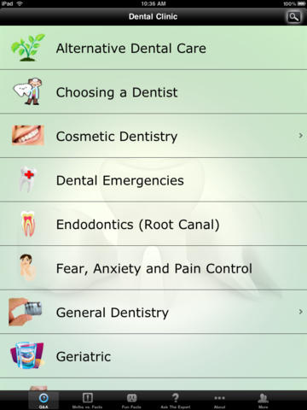

Figure 1: Show all menu that users can use.

As shown in Figure 1, when users open the application, they can see all of these menu items that they can select to see information.

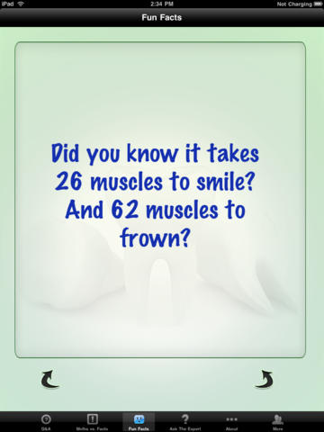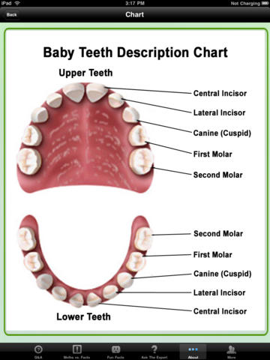

Figure 2: Show users the interface where they can select the features

As shown in Figure 2, users can select to see the useful information such as ‘Best ways to minimize your pain, fear and anxiety’ • ‘All of the important information you should know about your children’s dental care’ • ‘Knowing what all of your options are when missing one or more teeth’ • ‘What you should know about teeth whitening’.

### 2.1.1.2 Dr.Sunil Dental Clinic - Cosmetic, Oral & Implant Dentistry[2]

The website for Dental Center in Bangkok which provides foreign customers with advertisement of the clinic including the information about the services provided to customers. Customers can fill the document form to make an appointment. Customers also can use the provided QR code to call, email, and visit the website of dental clinic. But this website is only for customers and has only some information of dental care. Dentists cannot interact with customers directly.

### 

Figure 3: Show website of Dr.Sunil Dental Center

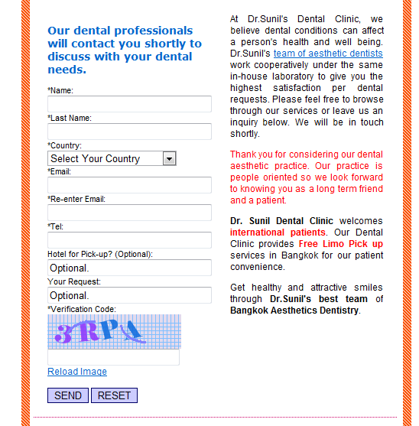

Figure 4: Show the contact with Dr. Sunil

### As shown in Figure 4, users can send their information to Dr. Sunil and wait for email to get an appointment

### 

### 

Figure 5: Show the cost of each treatment

As shown in Figure 5, customers can view the cost that they have to pay for each treatment.

**2.2 Technology Review**

**2.2.1 QR code** [3]

**2.2.1.1 QR code**

QR code (quick response code) is a type of [2D barcode](http://searchmobilecomputing.techtarget.com/definition/2D-barcode) that is used to provide easy access to information through a [smartphone](http://searchmobilecomputing.techtarget.com/definition/smartphone).

In this process, known as mobile tagging, the smartphone’s owner points the phone at a QR code and opens a [barcode reader](http://whatis.techtarget.com/definition/barcode-reader-POS-scanner-bar-code-reader-price-scanner) app which works in conjunction with the phone’s camera or a webcam. The reader interprets the code, which typically contains a call to action such as an invitation to download a mobile application, a link to view a video or an [SMS](http://searchmobilecomputing.techtarget.com/definition/Short-Message-Service) message inviting the viewer to respond to a poll. The phone’s owner can choose to act upon the call to action or click cancel and ignore the invitation. The QR code can recognize the URL website. Normally the URL website is difficult to keep because it’s too long and some of it is too complex. For QR code just scanning an item with a QR code provides a link to the website of that item.

**2.2.1.2 Zxing**[4]

Zxing or Zebra Crossing is a library for generating and detecting QR code. The library is being developed by Google with many other contributors. In iPhone, Zxing can work better than other QR Code libraries.

**2.2.1.3 Alternative Technology**

QR code is quite similar to 2D barcode and RFID (Radio-frequency identification). Both of them contain information and can using the information easier and faster. A barcode is normally used more than QR code and RFID because it is easier to encode and decode and also the cost is cheaper.

**2.2.1.3 The selection of this technology**

The reason why we choose QR code technology is because it is now very popular and most people use a smartphone. It is easy to use and comfortable. Using a QR code for identification, patients do not need to bring their appointment card when they come to the clinic. And another reason for using QR code is that is it faster and more reliable than using appointment card. We use Zxing to generate QR code to identify patients and their appointments.

**2.2.2 PhoneGap**

**2.2.2.1 PhoneGap**[5]

PhoneGap is an application framework that enables us to develop Mobile Application easier and build natively installed applications using HTML, HTML5 and JavaScript. Phone Gap is a Hybrid Application for Mobile. We can build user interface using traditional web development methods and skills, and use the PhoneGap container to deploy applications to different operating systems including Apple iOS, Google Android, Windows Phone, BlackBerry, HP WebOS, Symbian, and Bada. And they can be distributed via popular application market places (i.e. iTunes, Google App Market, Amazon Market, etc.)

**2.2.2.2 Alternative Technology**

Xcode and Titanium are integrated development environments (IDEs) that help create mobile applications which can be used on smartphones and tablets. Xcode includes a suite of development tools to build iOS mobile applications directly, while Titanium can create applications for many platforms, similarly to Phone Gap. It supports iOS, Android, and etc. The programming languages supported are JavaScript, HTML, CSS, Python, Ruby, and PHP.

**2.2.2.3 The selection of this technology**

For choosing PhoneGap to develop the application because it is an open source. We will create the mobile application by using HTML5, CSS, and JavaScript, all of which are supported by PhoneGap. And it can support 7 kinds of operating systems including iOS which is the mobile platform we have chosen for this project. PhoneGap will wrap the website to be the application. It contains the features that we have to use for this project such as camera function or database.

**2.2.3 HTML5**

**2.2.3.1 HTML5**

HTML5 is markup language used for creating websites. Evolved from the HTML standard, HTML5 has more features such as working with MAP system, and creating a graphic without flash. And HTML5 is supported by many operating systems on various devices such as Windows PC, MAC, iPhone, iPad, and Android-based mobile phones and tablets. It works with CSS and JavaScript and can be used not only to develop for the World Wide Web also but also to create mobile applications.

**2.2.3.2 Alternative Technology**

-

**2.2.3.3 The selection of this technology**

HTML5 has been selected for this project because it is the newest version of the HTML and supported by PhoneGap along with CSS and JavaScript. It can be used to develop both the dental clinic website and the mobile application of dental clinic.

**2.2.4 MySQL Server**[6]

**2.2.4.1 MySQL** **Server**

MySQL Server is a Rational Database Management System(RDBMS) that stores data in separate tables. MySQL Server is an open source database that can be used in many different platforms and is very fast, reliable, scalable, and easy to use. It also provides a high performance, multi-threading, and multiuser rational database management.

**2.2.4.2 Alternative Technology**

SQLite[[7]](http://www.sqlite.org/famous.html) is an self-contained in-process library of SQL database engine. To use SQLite, users do not need to install it, nor set up the SQLite Server. It runs on many operating systems such as OSX, Windows, Linux or Android.

**2.2.4.3 The selection of this technology**

The dental clinic system needs to store and maintain patients’ information as well as the information of treatments and others. All data need to be stored in a database that enables secure and stable management of the information. MySQL Server has been selected for this project because the database of dental clinic can potentially handle a large amount of data. SQLite is more suitable for a system that contains a small amount of data and has a limited storage.

**2.2.5 CakePHP[8]**

**2.2.5.1 CakePHP**

CakePHP is a framework which created by using PHP language, free, and open source. CakePHP designed based on MVC and ORM. They can work with PHP version 4 and 5, easier to use CRUD for database.

**2.2.5.2 Alternative Technology**

Zend framework[9] is both framework and library. They can use front controller pattern, factory pattern, strategy pattern, singleton pattern. Zend is the best framework if the application is using web services.

**2.2.5.3 The selection of this technology**

The dental clinic service system is a web application. Therefore, CakePHP is the framework that are mostly used for fast development and open source. Compare with Zend framework to the library is smaller.

**2.2.6 Architecture**

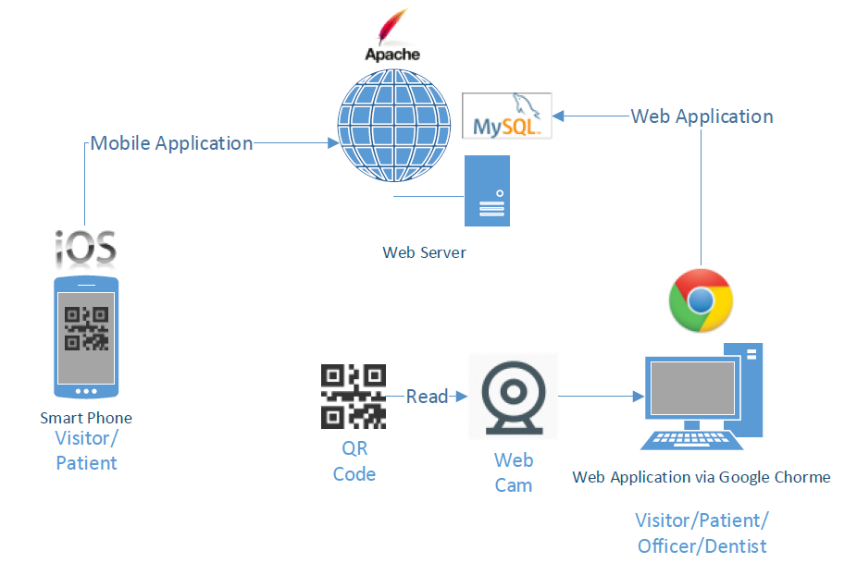

Figure 6: System Architecture

As shown in Figure 6, visitors and patients can use both the mobile application and the web application. Officers can use the web application to manage the schedule, add information via the Google Chrome browser, and identify patients by scanning QR code using a webcam. Dentists can manage their schedule and provide consultation to their patients using the web application. The system generates QR code for the patients and send it to their smartphone. The database of system is stored on the web server.

**Chapter Three: Quality Standard**

**3.1 ISO29110 for Very Small Entity(VSE)**

ISO29110 is a guide applies to a Very Small Entity (SVE), enterprise, organization, department or project up to 25 people, dedicate to software development. The Guide provides Project Management and Software Implementation process which integrate practices based on the selection of ISO/IEC 12207- System and Software Engineering - Software Life Cycle Processes and ISO/IEC 15289 Software Engineering - Software Life Cycle Process - guidelines for the content of software life cycle process information products(documentation) standard elements.

**3.1.1 Project Management Process**

The propose of the Project Management process is to establish and carry out in a systematic way the task of the software implementation project, which allows complying with the project’s objectives in the expected quality, time and cost.

**Selected process**

3.1.1.1 Project Planning Process

3.1.1.2 Project Plan Execution Process

3.1.1.3 Project Plan Assessment and Control Process

3.1.1.4 Project Closer Process

**3.1.2 Software Implementation process**

The purpose of the Software Implementation process is the systematic performance of the analysis, design, construction, integration and tests activities for new or modified software products according to the specified requirements.

**Selected process**

3.1.2.1 Software Implementation Initiation Process

3.1.2.2 Software Requirements Analysis Process

3.1.2.3 Software Architectural Design Process

3.1.2.4 Software Construction Process

3.1.2.5 Software Integration and Test Process

3.1.2.6 Software Delivery Process

**Chapter Four: Project Plan**

**4.1 Motivation**

Nowadays people in Thailand are more interested in dental care, and the number of dental clinics is increasing very fast, each with different number of patients. Dental clinics need to handle many patients and also many problems. Some of the typical examples are; patients forget about their appointment, patients do not have any knowledge about dental care, patients do not know the dentist schedule. Systems dedicated to serving dental care providers and patients will help solve these problems.

According to a recent research about mobile phone use, the number of smartphone users in 2013 increased by 29.1 percent from 2012 [10] and the number of people using mobile internet increased by 32 percent in 2013 [11]. People always use their phone to do many things such as entertainment, booking, shopping, communicating with others, accounting, and marketing.

In addition, such systems for dental clinics may improve the quality of services provided to their patients. For instance, most dental clinics rely on appointment cards to receive patients and keep track of their appointments. When patients arrive at the dental clinic, they have to provide their appointment card at the reception desk and the officer would have to look up the patient chart, which usually takes time. By integrating smartphones and QR codes into the workflow, our system can identify appointments faster and reduce the work of officer. For the Dental Clinic Services System, QR codes are more suitable than barcodes because they can be stored in and read from smartphones as well as traditional paper-based cards.

**4.2 Aim and Objectives**

The aim of this project is to develop a website and a mobile application that can help patients make appointments with dentists more easily and manage their appointments more efficiently. The system should support the management of the appointment schedule for both dentists and patients, remind patients about an upcoming appointment, provide dentists schedule to the visitors who want to make an appointment, reduce the time and work of dental clinic officers. The system will make sure that each patient has an appointment, gets proper consult from a dentist and also provide useful knowledge about dental treatment and dental care.

**Objectives**

1. To develop a system that consists of a web application and a mobile that provide services to helps dental clinics provide better services to their existing and potential customers:

* Appointment management
* Schedule sharing
* Online consultation
* Cost estimation
* Advertisement and promotion
* Providing knowledge of dental care Patient identification

2. To create a system that provides real-time information sharing among employees and customers of dental clinics.

**4.3 Deliverables and Limits**

**4.3.1 Deliverables**

The dental clinic system, the final product will consist of Software system

* **Web application**

The web application that supports sending appointment information, generating a QR code for each appointment, and authentication and authorizing patients by reading QR codes using a webcam. The dental web application that supports dental clinics which have many patients and solve the patients’ problems discussed in 4.1

* **Mobile application**

The dental mobile application for smartphones on the IOS operating system that supports dental clinics which have many patients and solve the patients’ problems discussed in 4.1

**Documentation**

• Project Proposal

• Project Plan

• Software Requirement Specification

• Software Design Document

• Testing Documents

-- Test Plan

-- Unit Test Document

-- System Test Document

• Traceability Record

• Software quality assurance

• Video presentation

• A1 poster for ShowPro

**4.3.2 Limits**

- The web application should run on Google chrome for better performance.

- Mobile devices (smartphones) should use since iOS6 or newer version.

- Mobile devices (smartphones) should support Edge, Wi-Fi, or 3G.

- Internet connection is required. Without Internet access, users cannot receive QR codes, and dentist’s schedule from the clinic. *(QR code contains patient information)

- Without internet connection, the mobile application provides the clinic’s information, dental care’s knowledge, promotion, and cost of dental care only.

**4.4 Future work**

**-** Support other major operating system platforms, for example; Android and Windows Mobile.

- Use other technologies to provide more convenient services to clinic officers and customers. For example, using RFID, officers will not need to use a camera to scan QR code but can just use RFID to verify patients.

**4.5 Schedule and Milestone**

This section presents the schedule and milestones that cover all the activities to be undertaken in the project. According to the current plan, the project will be completed by September, 2014.

**Proposal**

**Progress 1**

* Feature 1: User registration and authentication
* Feature 2: Schedule management

**Progress 2**

* Feature 3: Appointment management
* Feature 4: A dental clinic information and promotion
* Feature 5: Cost estimation of dental treatments

**Progress 3**

* Feature 6: Patient identification using QR code
* Feature 7: Dental care consulting and following up

**SE ShowPro**

**Final Progress**

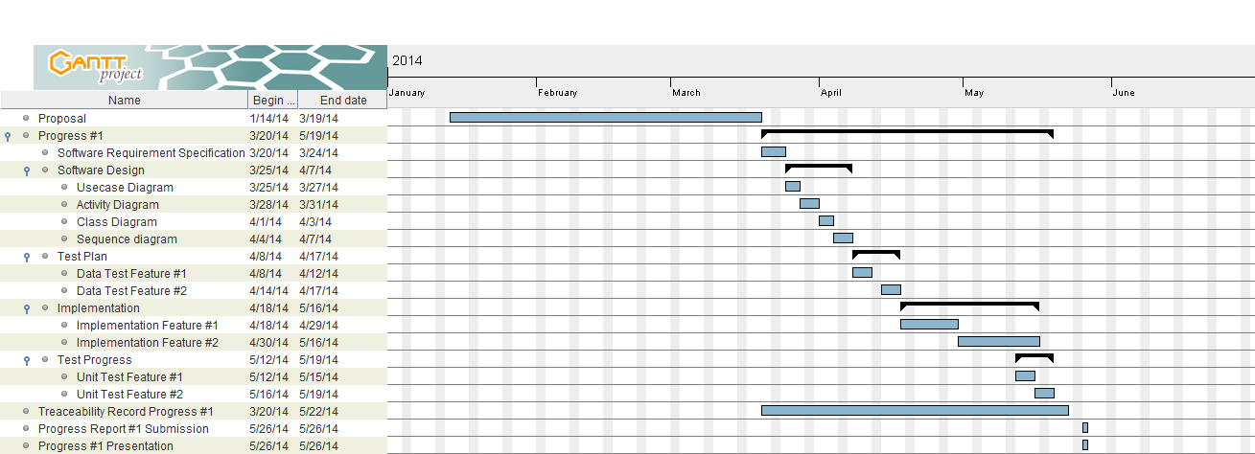

Figure 7: Milestone of Proposal and Progress 1

As shown in Figure 7, the proposal stage starts around January and continues until the mid-March.

Progress 1 starts around mid-March until mid-May.

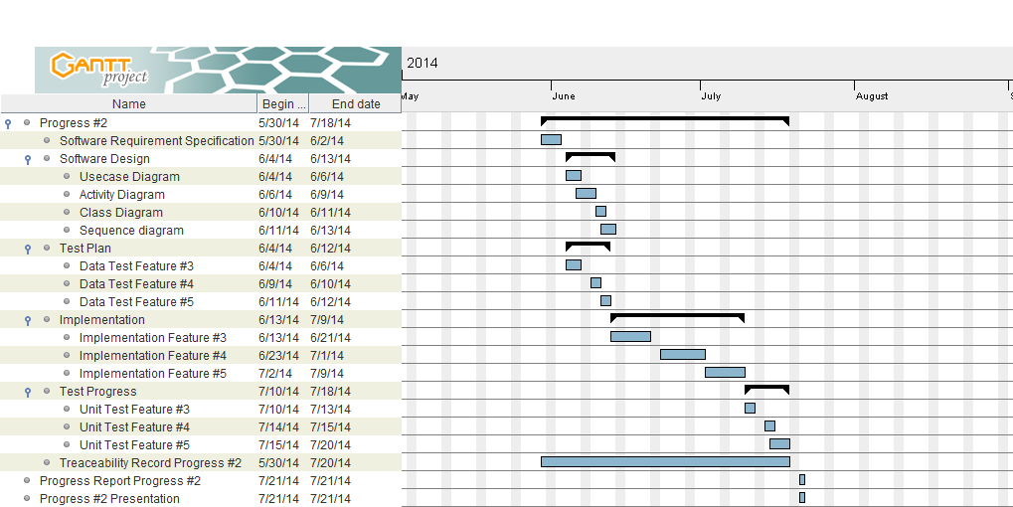Figure 8: Milestone of Progress 2

As shown in Figure 8, Progress 2 starts around mid-May and continues until mid-July.

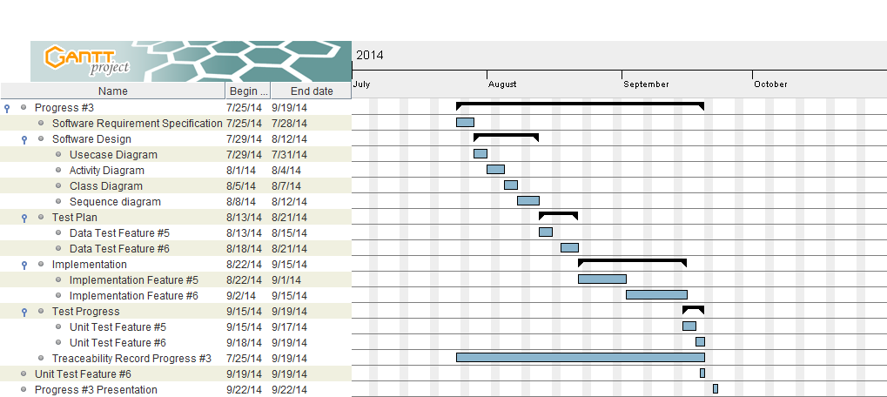

Figure 9: Milestone of Progress 3

As shown in Figure 9, Progress 3 starts around mid-August and continues until mid-September.

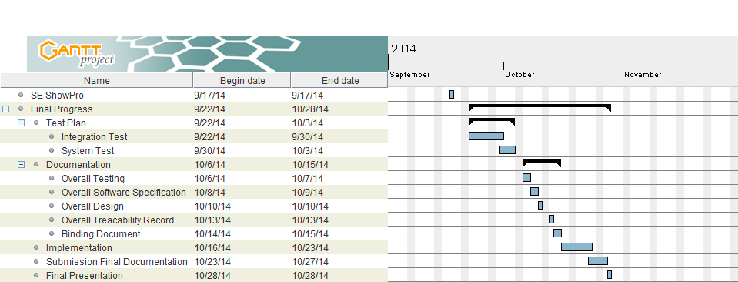

Figure 10: Milestone of SE ShowPro and Final Progress

As shown in Figure 10, SE ShowPro is scheduled for mid-September.

Final progress is from mid-September continues until mid-November.

**Chapter Five: References**

## [1]: Cosmetic Innovations, Inc., “Dental Clinic”

https://itunes.apple.com/us/app/dental-clinic/id391794242?mt=8

**[2]: Dr.Sunil Dental Clinic**

http://www.drsunildental.com/

[3]: [**Marc Lyne**](http://searchengineland.com/author/marc-lyne)**,“**[**What Is A QR Code And Why Do You Need One?**](http://searchengineland.com/what-is-a-qr-code-and-why-do-you-need-one-27588)**”**

<http://searchengineland.com/what-is-a-qr-code-and-why-do-you-need-one-27588>

[4]: [**Gregory Raiz**](http://www.quora.com/Gregory-Raiz)**, “What is the best QR decoder library for the iPhone?”**

<http://www.quora.com/What-is-the-best-QR-decoder-library-for-the-iPhone>

[5]: **PhoneGap, “Supported Features”**

<http://phonegap.com/about/features>

[6]: **MySQL, “What is MySQL?”**

<http://dev.mysql.com/doc/refman/4.1/en/what-is-mysql.html>

[7]: **SQLite, “Docmentation”**

<http://www.sqlite.org/>

[8]: **CakePHP**

<http://cakephp.org/>

### [9]: [Web Technology Expert's Notes](http://php-tutorial-php.blogspot.com/), “Difference Between Cakephp and Zend Framework”

http://php-tutorial-php.blogspot.com/2013/06/difference-between-cakephp-and-zend.html

[10]: **AtimeDesign,“วงการสมาร์ทโฟนไทยกับเว็บไซต์”**

<http://www.atimedesign.com/webdesign/%E0%B8%A7%E0%B8%87%E0%B8%81%E0%B8%B2%E0%B8%A3%E0%B8%AA%E0%B8%A1%E0%B8%B2%E0%B8%A3%E0%B9%8C%E0%B8%97%E0%B9%82%E0%B8%9F%E0%B8%99%E0%B9%84%E0%B8%97%E0%B8%A2%E0%B8%81%E0%B8%B1%E0%B8%9A%E0%B9%80%E0%B8%A7/>

[11]: **thumbsup, “Increased of mobile users push web responsive design”**

http://thumbsup.in.th/2013/04/increase-mobile-users-push-web-responsive-design/

**Questions and Answers from presentation**

**1. Why only chrome?**

* Actually this application can use in other web browser, but it might not in a good performance. And we use Google chrome for testing a website because other browser using different command and coding. In this limited time, it is hard to support in every web browser.

**2. Why only ios7?**

* At the first time, we think now ios7 is stable and reliable, so we just support only for ios7. But from the advice from adviser we think we should support since ios6.

**3. Online consult: why not Skype, Line?**

* Because online consulting does not like chatting so, we think it shouldn’t be real-time like a Skype or Line. For our application patients can leave their question and the dentist will come and answer.

**4. What is the sever side?**

* We use web server from CakePHP framework instead of Apache.

**5. Have other way to send the QR code (email, sms)?**

* We can send the QR code through application and email, but for sms we cannot send the QR code, so we send the patient id instead.

**6. If there’s delay or change how do you manage?**

* Time of treatment is depend on patients’ symptom. For example for tooth cleaning is 20 minutes, for fluoride gel application is 15 minutes.

**7. How about supporting ios6 also?**

* We think we should support ios6 also. For the other lower ios we does not have the device to test it, so in other lower ios might in not good performance.

**8. How about building a kiosk(QR)?**

* We think building a kiosk is better because it will reduce officers’ work

**9. Web service framework php or …..?**

* We design to use CakePHP frame work because it is an open source, friendly license and have a helper in developing AJAX, Javascript, HTML, form and else more.

**10. Knowledge customized for each other?**

* Provide the knowledge for each patient’s symptom.

**11. Online consulting another feature for mobile application?**

* No, because for our application patients can leave questions, and the dentist will come to answer those questions. It not mean that the dentist has to be always online, but they can answer when have a free time.